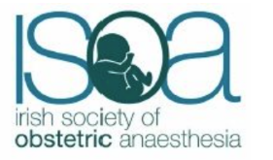

Abstract submission guidelines

Please note there are three different abstract submission forms. Choose the most appropriate form:

1) Original research
2) Case reports
3) Short report QI/Audit

Please also fill in the Contact Details Form

Abstract Guidelines

Maximum words: 200 for Original Research, 150 for Short Reports and Case Reports

Maximum authors: 4

Please use the headings as listed.

Only abstracts which comply with the IMJ formatting rules, as detailed in the relevant forms, will be considered for abstract publication in the IMJ.

The named presenter must be registered for the conference in order for abstracts to be published.

If submitting a case report – your submission email must contain a statement regarding patient consent for publication. If identifiable images or descriptors are used, then the IMJ Consent Form must be completed.

Please email your completed abstract submission form and Contact Details form to ISOAsubmission@gmail.com by 5pm Friday October 31st 2025.

Late applications will not be accepted.

