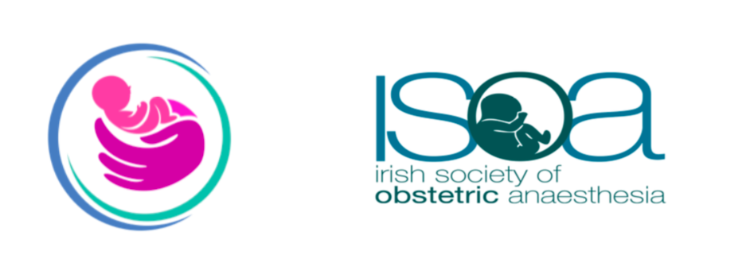

Please complete this form in BLOCK CAPITALS: This form should be returned to:

Catherine Finn, Department of Anaesthesia, Rotunda Hospital, Parnell Square, Dublin 1

Telephone: 01- 817 1794 Fax: 01- 8730 347 Email: cfinn@rotunda.ie
Name of meeting: | Irish Society of Obstetric Anaesthesia & Northern Ireland Obstetric Anaesthesia Network Webinar  Friday 23rd April 2021  No registration fee  5 PCS points (CAI)
Name
Email
Mobile telephone
Current hospital address

